Flow vs P

**Figure S1.** We used the pressure of the optical cavity to identify periods where nearly no gas is available in the layers. Here we set the a very small number of 10-10 ml min-1 to the gas flow rate as the cavity pressure drop to a small value lower than 19.9 mbar. Data with a total number of 14509 has been identified as bubble-free layers. We also calculated the proportion of bubble-free layers per meter that displayed in the lower panel.

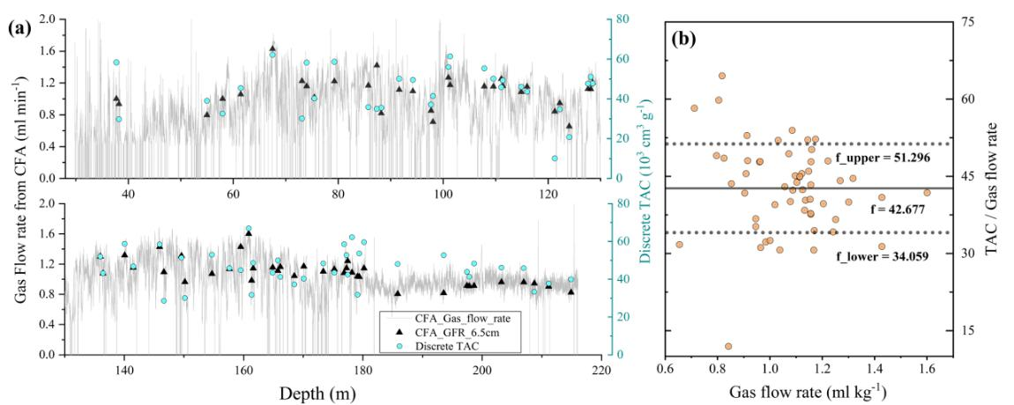

**Figure S2**. Continuous TAC was calculated based on the relationship between CFA gas flow rate and discrete TAC. Plot **(a)** shows the discrete TAC and gas flow rate from CFA on the depth scale. Discrete TAC and the overlapped mean gas flow rate from CFA are also plotted. A temporal lagging of 22 s was taken into consideration in calculating the averaged gas flow rate. 22 s was the system responding time that described in S5.Plot **(b)** shows the ratio of 69 discrete TAC values and overlapped mean CFA gas flow rates that shown in (a). 56 data that stable gas flow rate was presented as solid cycles. These values were selected when the mean gas flow rate within 12 cm larger than 5 times of the standard deviation, and no bubble-free layer in 12 cm depth coverage. Mean value of the ratios ( TAC / Gas flow rate ) was used as a scaling factor to calculate the continuous TAC. ±1 standard deviation of the data was used as their upper (or lower) limits.

**Equation S (1).** Continuous TAC was also calculated based on its intrinsically physical relationship with gas flow rate. The equation was describe as follows:

 (1)

The melt rate was taken from a mean value of 5.4 cm min-1 that measured simultaneously with ice samples. Upper (lower) limits to this parameter were estimated to be 4.5 cm min-1 and 6.3 cm min-1, taken from the average melt rate ±1 standard deviation. The density for each core segments were converted from the ice mass that measured before CFA measurement. We take a value of 0.84 g m-3 that is the mean value in core segments below 30 m. Upper (lower) limits to this parameter were estimated to be 0.81 to 0.88 g m-3, taken from the average density ±1 standard deviation. S is the inner diameter of melter of 2.26×2.26 cm.

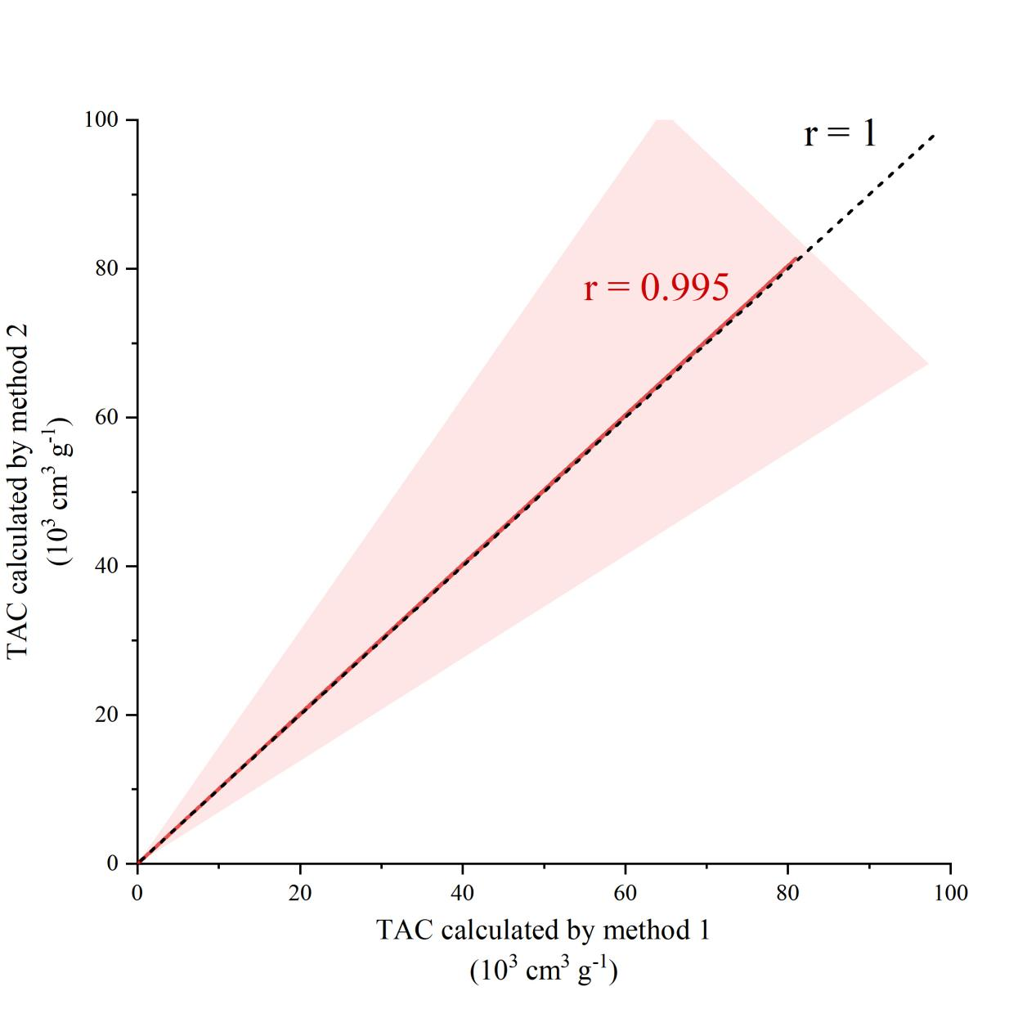

**Figure S3.** The TAC ratios that calculated by two independent methods, as well as its uncertainty intervals.

**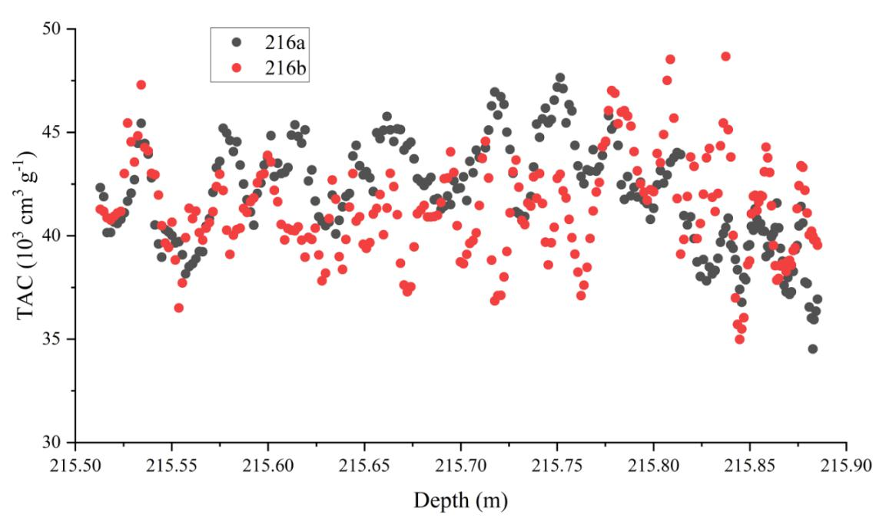**

**Figure S4**. The overlapped core section that used for duplicate measurements. The standard deviation of the TAC differences between the overlapped sections is calculated to be 3.50 (N=241).

precision assessment

**Figure S5. (a)** shows the normalized Gas Flow Rate (GFR) as a response to a stepwise changes between 1.90 to 2.15 cm min-1 (black dots). A fit to the data using a scaled version of the cumulative distribution function (cdf) of a log normal distribution is shown as a dashed red line. Following **(b)** shows the derivative of the normalized step response in (a), with the derivative of the cdf fit shown as a dashed red line. The transfer function Ĝ(f) ( f = dGFR / dt ) in **(c)** is the Fourier transform of the normalized derivative that shown in (b). The magnitude of the transfer function describes how the amplitude of a periodic input signal of a certain frequency is damped when analyzed by the system. Following figure c shows the magnitude of the transfer function (black dots) of the system. The transfer functions of the derivative of the cdf fit represents the theoretical zero-noise case (dashed red line).

peak_annual ccumalative

**Figure S6**. Using the automatic ‘findpeaks’ tool that provided by Origin software (version 7.0) (OriginLab), we detected 154 positive peaks from top 66.78 m (53.57 we m) record. The depth intervals between these peaks were also calculated, then we took a 10-point moving average to them and plotted results on depth scale that shown in Figure S7. The annual cumulative mass (red line) and its uncertainty intervals that calculated based on the 2p model are also plotted.